PROJECT

Touch Controlled Light Using ARDUINO UNO

In this project I made a touch sensor using a coin that works based on arduino Capacitive Sensing Library. I used this sensor to turn on and turn off LED by touching on it. Capacitive sensors can detect anything that is conductive or that has a significantly different permitivity than air, like a human body or hand.

The capacitive Sensor library turns two or more Arduino pins into a capacitive sensor, which can sense the electrical capacitance of the human body.

Circuit and Working

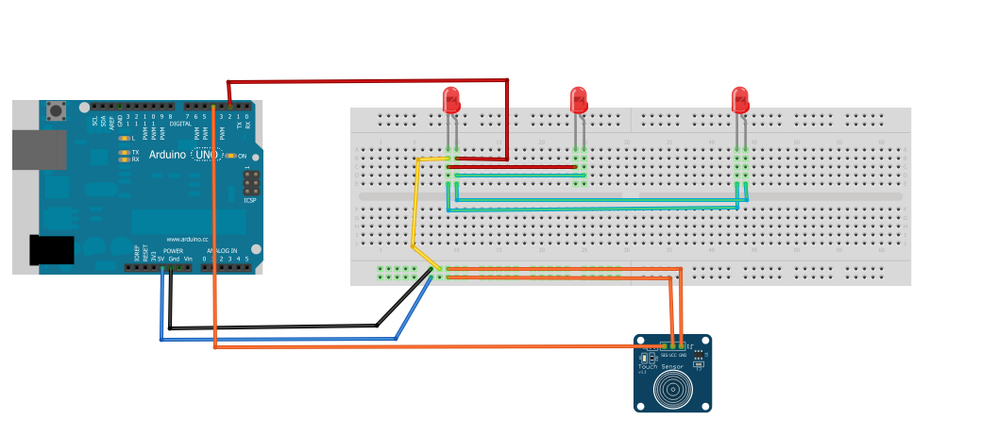

PIN CONNECTIONS

Negative pin of led connects with digital pin 2 and positive pin connects with the ground and same for other two. 5volt pin from arduino connects with the bread board and ground with bread board as shown and VCC pin of touch sensor connects with the 5v on bread board and GND pin to ground on bread board SIG pin is connect with digital pin 2 on arduino.

WORKING

Whenever you touches the sensor it changes the previous state, that is turning on or off the LED.

CODE

#define touchpin 4

int ledPin = 2;

void setup() {

pinMode(touchpin, INPUT);

pinMode(ledPin, OUTPUT);

}

void loop() {

int touchValue = digitalRead(touchpin);

if (touchValue == HIGH){

digitalWrite(ledPin, HIGH);

}

else{

digitalWrite(ledPin,LOW);

}

delay(300);

}

